Ideation Phase
Brainstorm & Idea Prioritization

Date | 30 September 2026
Team ID | SWTID-2026-5086
Project Name | AI WeatherWise API
Maximum Marks | 4 Marks

Brainstorm & Idea Prioritization :
Step-1:
Team Gathering:
Team of 5 members (B.Sc CS 3rd Yr). Roles assigned - Team Lead , API Developer, UI Designer, Tester & Documenter.
The goal:
To build an AI-powered weather intelligence system that is simple, multilingual, and useful for common people and farmers in Tamil Nadu, not just technical users.
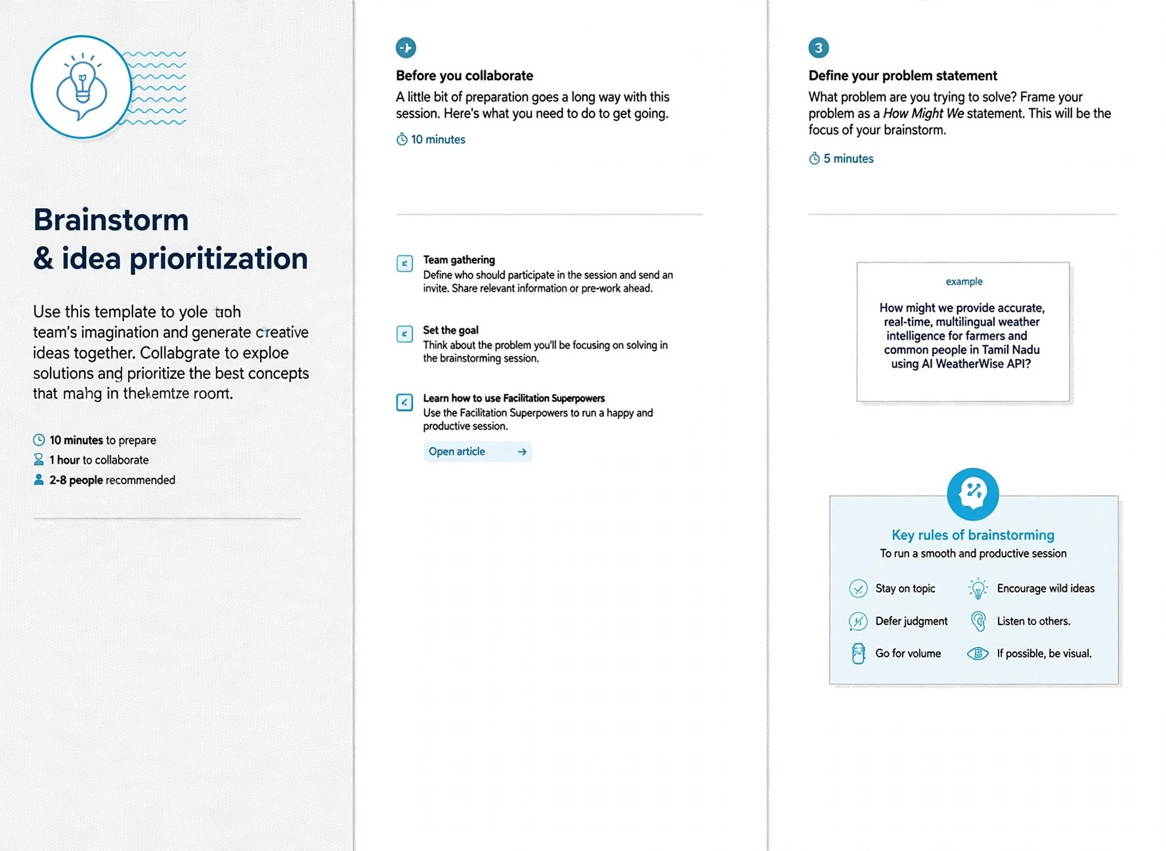

Step-2: Brainstorm, Idea Listing and Grouping
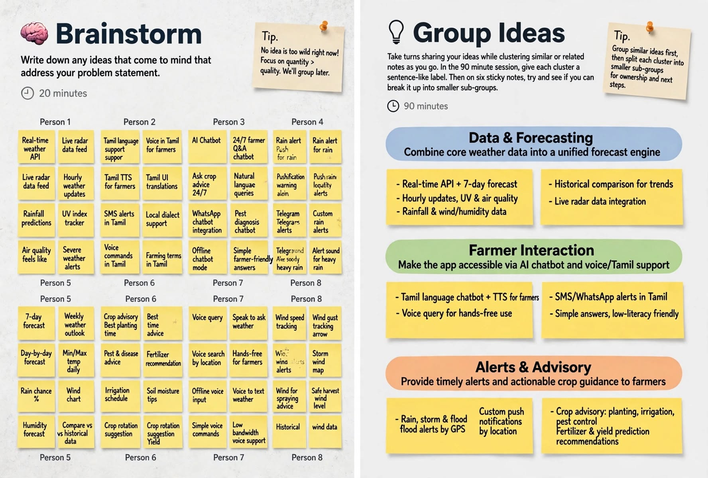

Step-3: Idea Prioritization
